



Department of Electrical Engineering

A PROJECT REPORT ON

**WattWatch: Smart Power Usage Dashboard**

Submitted by

|  |  |
| --- | --- |
|  | |
| PRN Number | Name of Student |
| 24510022 | Aditya Deshmukh |
| 24510038 | Manasvi Gundawar |
| 23610046 | Pranay Gawande |

In partial fulfilment of S.Y. B.Tech (Electrical Engineering)

Term work of course

“Minor - Electrical Measurements Lab” [ELMNR302– Sem - III]

CERTIFICATE

Academic Year : 2025-26

This is to certify that the project report entitled “Energy Analytics Dashboard”

Submitted by

|  |  |
| --- | --- |
| PRN Number | Name of Student |
| 24510022 | Aditya Deshmukh |
| 24510038 | Manasvi Gundawar |
| 23610046 | Pranay Gawande |

is a bonafide work carried out by above students under the supervision of Ms. Saba Shaikh & Mr. Sachin Shelar and it is approved for the partial fulfilment of the end semester examination of course “Electrical Measurements” [ELPCC303 – Sem - III] of Second Year B. Tech Electrical Engineering program.

|  |  |
| --- | --- |
| Ms. Saba Shaikh / Mr. Sachin Shelar  Internal Guide  Department of Electrical Engineering | Dr. K. S. Gadgil  Head of Department  Department of Electrical Engineering |

Date:

Place: Pune

Abstract

The project **“WattWatch: Smart Power Usage Dashboard”** focuses on analyzing and visualizing electrical energy data stored in CSV files.  
It allows users to upload real-time or recorded meter data and view power parameters such as **Voltage**, **Power**, and **Power Factor** in an interactive dashboard.

The system automatically filters data by time and calculates the **average voltage**, **total energy consumption**, and **estimated electricity bill**.  
This tool enables students and professionals to better understand energy patterns, detect anomalies, and estimate costs effectively.  
The dashboard is built using **Python**, **Streamlit**, **Matplotlib**, and **Pandas**, and deployed on **Streamlit Cloud** for easy access.

❑❑❑

**Table of Contents**

Chapter 1:Introduction…………………………………………………………..5

Chapter 2: Problem statement & Objectives 6

* 1. Problem statement 6
  2. Objectives 6

Chapter 3: Software Design 6

3.1. System overview………………………………………………………..6

3.2 Modules………………………………………………………………….6

3.3 Tools and Libraries used…………………………………………………7

3.4 Flow of Operation………………………………………………………..7

Chapter 4: Member work sheet 7

Chapter 5: Result and Output 8

5.1.Output Screenshot………………………………………………………………………9

Chapter 6: Applications, Future Scope and Conclusion………………………..11

# **Chapter : 1 Introduction**

Energy monitoring is crucial in both residential and industrial setups for effective power management and cost reduction.  
Traditional meters provide limited insight, as they only show total consumption without visual analysis.  
The **WattWatch** project bridges this gap by transforming raw electrical meter data into meaningful visual insights.  
By reading CSV data logs, users can analyze variations in **voltage, power factor, and power usage** over time.

This project encourages better understanding of power utilization and helps identify time periods of higher energy consumption.  
It is designed to support learning in the **Industrial Electrical Engineering Minor** by combining programming (IT) and electrical concepts.

**Chapter 2: Problem**

**statement & Objectives**

2.1 Problem statement

Electrical energy data generated by meters is often complex and difficult to interpret.  
Without a proper visualization tool, users struggle to identify energy usage patterns or understand why their electricity bills fluctuate.  
There is a need for a simple, web-based tool that can process such data, generate graphs, and calculate estimated costs automatically.

2.2 Objectives

* To read and analyze power data from CSV files.
* To visualize key electrical parameters – Voltage, Power, and Power Factor.
* To allow users to select a specific time range for analysis.
* To calculate total energy consumption and estimated billing.
* To generate downloadable filtered data and reports.

**Chapter 3: Software Design**

**3.1.System Overview:**

The system is built using Python and the Streamlit framework, which creates an interactive web-based dashboard.  
It processes CSV data and displays results in real-time using line charts and summary statistics.

**3.2Modules:**

1. CSV File Input – Reads smart meter data from a CSV file.
2. Data Processing – Cleans missing or invalid entries.
3. Visualization – Plots voltage, power, and power factor graphs.
4. Computation – Calculates average voltage, power, and energy.
5. Billing Module – Estimates the cost based on user-specified ₹/kWh.
6. Download Option – Provides filtered dataset for analysis.

**3.3Tools and Libraries Used:**

* Streamlit – Web dashboard interface
* Pandas – Data cleaning and analysis
* Matplotlib – Data visualization
* NumPy – Numerical computation
* Python 3.11 – Programming language

**3.4Flow of Operation:**

1. Upload CSV data
2. Parse and clean dataset
3. Convert time column to datetime format
4. Allow time range selection
5. Generate summary statistics
6. Plot graphs for visualization
7. Display average readings and estimated bill
8. Download filtered data

**Chapter 4: Member work Sheet**

Following table gives the details of the work allotted and completed by each member.

|  |  |  |  |
| --- | --- | --- | --- |
| Sr. No. | Member Name | Work done | Sign of other  members |
| 1 | Aditya Deshmukh | Coding, data analysis, dashboard design. |  |
| 2 | Manasvi Gundawar | UI enhancement, data preprocessing, testing |  |
| 3 | Pranay Gawande | |  | | --- | |  |  |  | | --- | | Documentation, report formatting, | |  |

**Chapter 5: Result and Output**

**Result:**

The dashboard successfully displays:

* Average daily voltage, power, and power factor.
* Total energy consumption (kWh).
* Estimated electricity bill.
* Visual time-based power trend analysis

**Example result for one day’s data:**

Average Voltage (V) - 235.12

Average Power (W) - 33.82

Power Factor - 0.347

Total Energy (kWh) - 0.8115

Estimated Bill (₹ @ 8.0/kWh) - 6.49

# **Live Dashboard Link**

<https://electrical-minor-b7n3g2ewjrbmqhwzmofkmd.streamlit.app/>

**Output Screenshot**

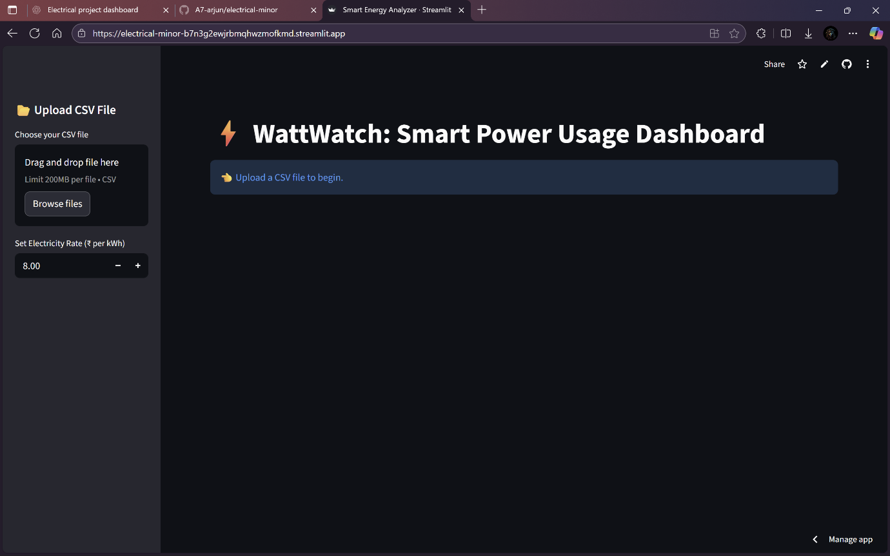

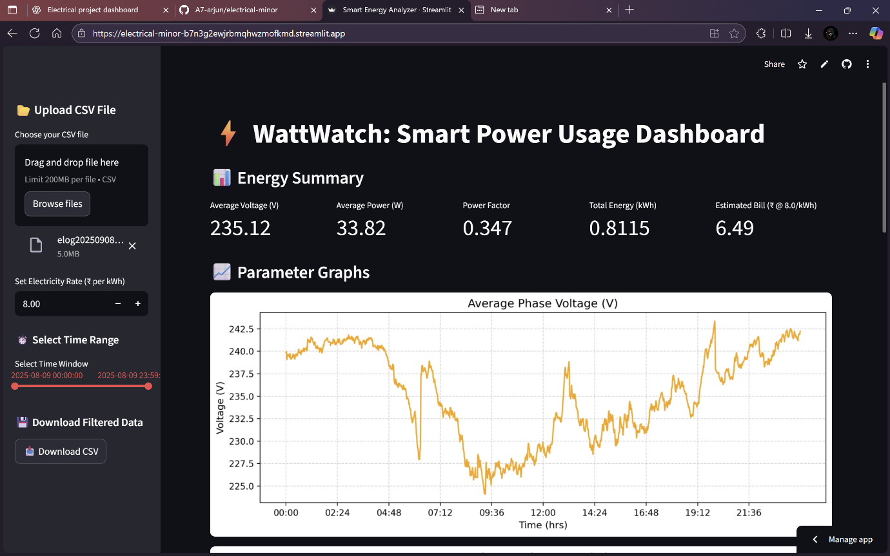

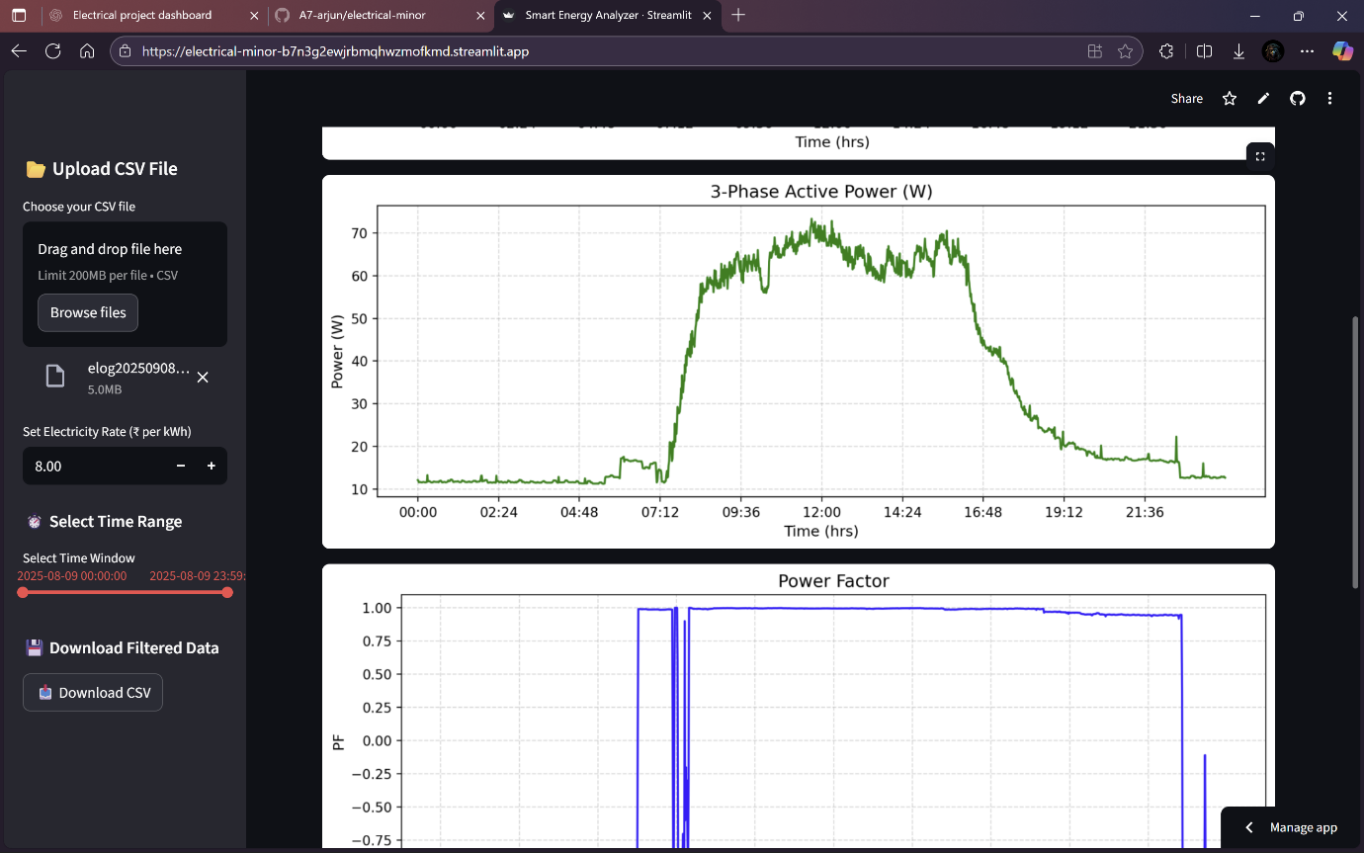

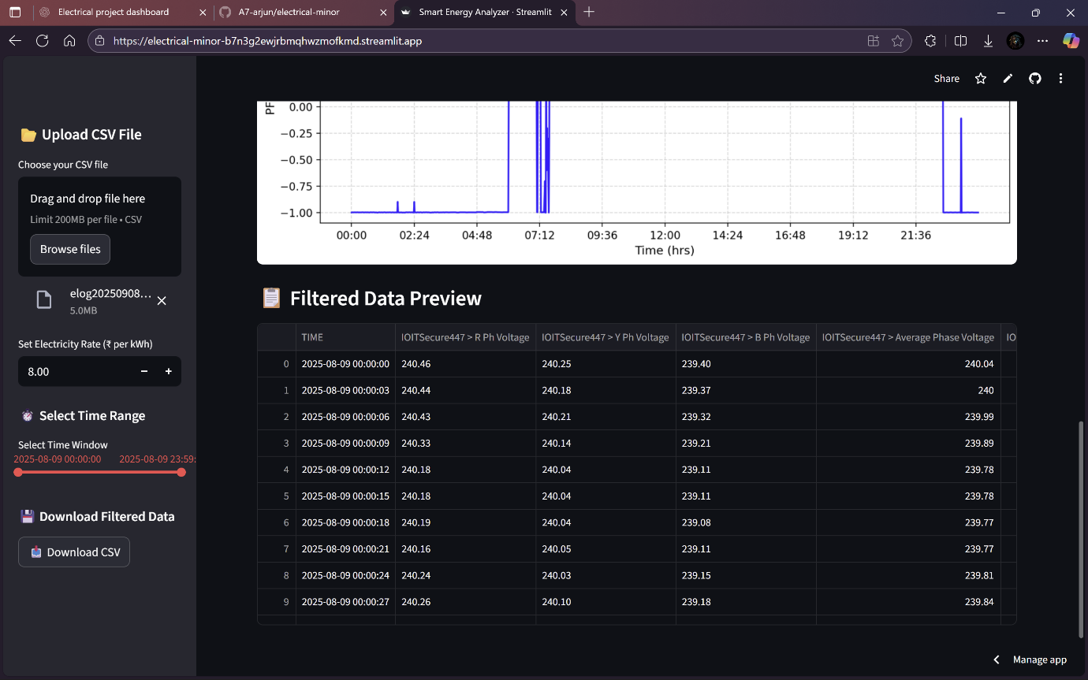

**Chapter 6:Application,Future Scope and Conclusion**

# **7.1.Applications**

* Home and apartment energy monitoring
* Industrial power analysis
* Smart grid prototype visualization
* Academic research and student projects

**7.2.Future Scope**

1. Integrate with live smart meters via Modbus or DLMS protocol.
2. Store readings on a cloud database for real-time monitoring.
3. Develop an Android app for mobile access.
4. Include alerts for abnormal voltage or power usage.
5. Add AI-based load forecasting and bill prediction features.

**7.3.Conclusion**

The **WattWatch:Smart Power Usage Dashboard** provides an efficient way to interpret and visualize electrical data.  
It simplifies complex CSV readings into user-friendly visuals, empowering users to understand energy consumption patterns and billing.  
The system is flexible, lightweight, and accessible through any web browser.